Assignment 4

Srilaya Valmeekam

03-18-2023

library(readr)  
Pharmaceuticals_SLV <- read.csv("~/Downloads/Pharmaceuticals.csv")

library(ggplot2)  
library(factoextra)

## Welcome! Want to learn more? See two factoextra-related books at https://goo.gl/ve3WBa

library(flexclust)

## Loading required package: grid

## Loading required package: lattice

## Loading required package: modeltools

## Loading required package: stats4

library(cluster)  
library(tidyverse)

## ── Attaching packages  
## ───────────────────────────────────────  
## tidyverse 1.3.2 ──

## ✔ tibble 3.1.8 ✔ dplyr 1.0.10  
## ✔ tidyr 1.2.1 ✔ stringr 1.4.1   
## ✔ purrr 0.3.4 ✔ forcats 0.5.2   
## ── Conflicts ────────────────────────────────────────── tidyverse_conflicts() ──  
## ✖ dplyr::filter() masks stats::filter()  
## ✖ dplyr::lag() masks stats::lag()

summary(Pharmaceuticals_SLV)

## Symbol Name Market_Cap Beta   
## Length:21 Length:21 Min. : 0.41 Min. :0.1800   
## Class :character Class :character 1st Qu.: 6.30 1st Qu.:0.3500   
## Mode :character Mode :character Median : 48.19 Median :0.4600   
## Mean : 57.65 Mean :0.5257   
## 3rd Qu.: 73.84 3rd Qu.:0.6500   
## Max. :199.47 Max. :1.1100   
## PE_Ratio ROE ROA Asset_Turnover Leverage   
## Min. : 3.60 Min. : 3.9 Min. : 1.40 Min. :0.3 Min. :0.0000   
## 1st Qu.:18.90 1st Qu.:14.9 1st Qu.: 5.70 1st Qu.:0.6 1st Qu.:0.1600   
## Median :21.50 Median :22.6 Median :11.20 Median :0.6 Median :0.3400   
## Mean :25.46 Mean :25.8 Mean :10.51 Mean :0.7 Mean :0.5857   
## 3rd Qu.:27.90 3rd Qu.:31.0 3rd Qu.:15.00 3rd Qu.:0.9 3rd Qu.:0.6000   
## Max. :82.50 Max. :62.9 Max. :20.30 Max. :1.1 Max. :3.5100   
## Rev_Growth Net_Profit_Margin Median_Recommendation Location   
## Min. :-3.17 Min. : 2.6 Length:21 Length:21   
## 1st Qu.: 6.38 1st Qu.:11.2 Class :character Class :character   
## Median : 9.37 Median :16.1 Mode :character Mode :character   
## Mean :13.37 Mean :15.7   
## 3rd Qu.:21.87 3rd Qu.:21.1   
## Max. :34.21 Max. :25.5   
## Exchange   
## Length:21   
## Class :character   
## Mode :character   
##   
##   
##

#Task 1  
#Use only the numerical variables (1 to 9) to cluster the 21 firms.   
#Justify the various choices #made in conducting the cluster analysis,   
#such as weights for different variables, the specific   
#clustering algorithm(s) used, the number of clusters formed, and so on.   
SLV <- na.omit(Pharmaceuticals_SLV)  
SLV

## Symbol Name Market_Cap Beta PE_Ratio ROE ROA  
## 1 ABT Abbott Laboratories 68.44 0.32 24.7 26.4 11.8  
## 2 AGN Allergan, Inc. 7.58 0.41 82.5 12.9 5.5  
## 3 AHM Amersham plc 6.30 0.46 20.7 14.9 7.8  
## 4 AZN AstraZeneca PLC 67.63 0.52 21.5 27.4 15.4  
## 5 AVE Aventis 47.16 0.32 20.1 21.8 7.5  
## 6 BAY Bayer AG 16.90 1.11 27.9 3.9 1.4  
## 7 BMY Bristol-Myers Squibb Company 51.33 0.50 13.9 34.8 15.1  
## 8 CHTT Chattem, Inc 0.41 0.85 26.0 24.1 4.3  
## 9 ELN Elan Corporation, plc 0.78 1.08 3.6 15.1 5.1  
## 10 LLY Eli Lilly and Company 73.84 0.18 27.9 31.0 13.5  
## 11 GSK GlaxoSmithKline plc 122.11 0.35 18.0 62.9 20.3  
## 12 IVX IVAX Corporation 2.60 0.65 19.9 21.4 6.8  
## 13 JNJ Johnson & Johnson 173.93 0.46 28.4 28.6 16.3  
## 14 MRX Medicis Pharmaceutical Corporation 1.20 0.75 28.6 11.2 5.4  
## 15 MRK Merck & Co., Inc. 132.56 0.46 18.9 40.6 15.0  
## 16 NVS Novartis AG 96.65 0.19 21.6 17.9 11.2  
## 17 PFE Pfizer Inc 199.47 0.65 23.6 45.6 19.2  
## 18 PHA Pharmacia Corporation 56.24 0.40 56.5 13.5 5.7  
## 19 SGP Schering-Plough Corporation 34.10 0.51 18.9 22.6 13.3  
## 20 WPI Watson Pharmaceuticals, Inc. 3.26 0.24 18.4 10.2 6.8  
## 21 WYE Wyeth 48.19 0.63 13.1 54.9 13.4  
## Asset_Turnover Leverage Rev_Growth Net_Profit_Margin Median_Recommendation  
## 1 0.7 0.42 7.54 16.1 Moderate Buy  
## 2 0.9 0.60 9.16 5.5 Moderate Buy  
## 3 0.9 0.27 7.05 11.2 Strong Buy  
## 4 0.9 0.00 15.00 18.0 Moderate Sell  
## 5 0.6 0.34 26.81 12.9 Moderate Buy  
## 6 0.6 0.00 -3.17 2.6 Hold  
## 7 0.9 0.57 2.70 20.6 Moderate Sell  
## 8 0.6 3.51 6.38 7.5 Moderate Buy  
## 9 0.3 1.07 34.21 13.3 Moderate Sell  
## 10 0.6 0.53 6.21 23.4 Hold  
## 11 1.0 0.34 21.87 21.1 Hold  
## 12 0.6 1.45 13.99 11.0 Hold  
## 13 0.9 0.10 9.37 17.9 Moderate Buy  
## 14 0.3 0.93 30.37 21.3 Moderate Buy  
## 15 1.1 0.28 17.35 14.1 Hold  
## 16 0.5 0.06 -2.69 22.4 Hold  
## 17 0.8 0.16 25.54 25.2 Moderate Buy  
## 18 0.6 0.35 15.00 7.3 Hold  
## 19 0.8 0.00 8.56 17.6 Hold  
## 20 0.5 0.20 29.18 15.1 Moderate Sell  
## 21 0.6 1.12 0.36 25.5 Hold  
## Location Exchange  
## 1 US NYSE  
## 2 CANADA NYSE  
## 3 UK NYSE  
## 4 UK NYSE  
## 5 FRANCE NYSE  
## 6 GERMANY NYSE  
## 7 US NYSE  
## 8 US NASDAQ  
## 9 IRELAND NYSE  
## 10 US NYSE  
## 11 UK NYSE  
## 12 US AMEX  
## 13 US NYSE  
## 14 US NYSE  
## 15 US NYSE  
## 16 SWITZERLAND NYSE  
## 17 US NYSE  
## 18 US NYSE  
## 19 US NYSE  
## 20 US NYSE  
## 21 US NYSE

row.names <- SLV[,1]  
Pharmaceuticals1 <- SLV[,3:11]  
head(Pharmaceuticals1)

## Market_Cap Beta PE_Ratio ROE ROA Asset_Turnover Leverage Rev_Growth  
## 1 68.44 0.32 24.7 26.4 11.8 0.7 0.42 7.54  
## 2 7.58 0.41 82.5 12.9 5.5 0.9 0.60 9.16  
## 3 6.30 0.46 20.7 14.9 7.8 0.9 0.27 7.05  
## 4 67.63 0.52 21.5 27.4 15.4 0.9 0.00 15.00  
## 5 47.16 0.32 20.1 21.8 7.5 0.6 0.34 26.81  
## 6 16.90 1.11 27.9 3.9 1.4 0.6 0.00 -3.17  
## Net_Profit_Margin  
## 1 16.1  
## 2 5.5  
## 3 11.2  
## 4 18.0  
## 5 12.9  
## 6 2.6

Pharmaceuticals2 <- scale(Pharmaceuticals1)  
head(Pharmaceuticals2)

## Market_Cap Beta PE_Ratio ROE ROA Asset_Turnover  
## 1 0.1840960 -0.80125356 -0.04671323 0.04009035 0.2416121 -5.121077e-16  
## 2 -0.8544181 -0.45070513 3.49706911 -0.85483986 -0.9422871 9.225312e-01  
## 3 -0.8762600 -0.25595600 -0.29195768 -0.72225761 -0.5100700 9.225312e-01  
## 4 0.1702742 -0.02225704 -0.24290879 0.10638147 0.9181259 9.225312e-01  
## 5 -0.1790256 -0.80125356 -0.32874435 -0.26484883 -0.5664461 -4.612656e-01  
## 6 -0.6953818 2.27578267 0.14948233 -1.45146000 -1.7127612 -4.612656e-01  
## Leverage Rev_Growth Net_Profit_Margin  
## 1 -0.2120979 -0.5277675 0.06168225  
## 2 0.0182843 -0.3811391 -1.55366706  
## 3 -0.4040831 -0.5721181 -0.68503583  
## 4 -0.7496565 0.1474473 0.35122600  
## 5 -0.3144900 1.2163867 -0.42597037  
## 6 -0.7496565 -1.4971443 -1.99560225

fviz_nbclust(Pharmaceuticals2, kmeans, method = "wss") +  
 labs(subtitle = "Elbow Method")

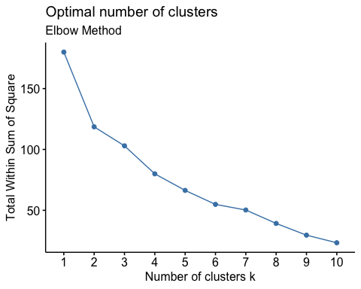

fviz_nbclust(Pharmaceuticals2, kmeans, method = "silhouette") + labs(subtitle = "Silhouette Method")

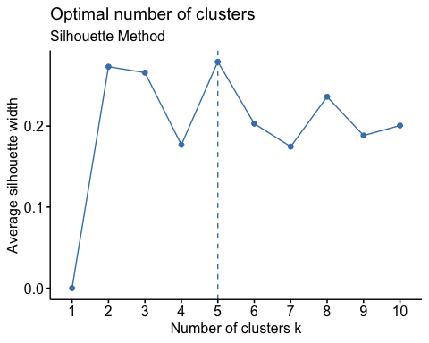

fviz_nbclust(Pharmaceuticals2, kmeans, method = "gap_stat") + labs(subtitle = "Gap Stat Method")

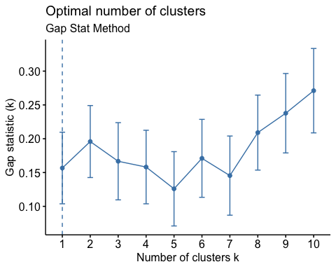

set.seed(64060)  
k5 <- kmeans(Pharmaceuticals2, centers = 5, nstart = 25)  
k5 $centers

## Market_Cap Beta PE_Ratio ROE ROA Asset_Turnover  
## 1 -0.87051511 1.3409869 -0.05284434 -0.6184015 -1.1928478 -0.4612656  
## 2 -0.43925134 -0.4701800 2.70002464 -0.8349525 -0.9234951 0.2306328  
## 3 -0.76022489 0.2796041 -0.47742380 -0.7438022 -0.8107428 -1.2684804  
## 4 -0.03142211 -0.4360989 -0.31724852 0.1950459 0.4083915 0.1729746  
## 5 1.69558112 -0.1780563 -0.19845823 1.2349879 1.3503431 1.1531640  
## Leverage Rev_Growth Net_Profit_Margin  
## 1 1.36644699 -0.6912914 -1.320000179  
## 2 -0.14170336 -0.1168459 -1.416514761  
## 3 0.06308085 1.5180158 -0.006893899  
## 4 -0.27449312 -0.7041516 0.556954446  
## 5 -0.46807818 0.4671788 0.591242521

fviz_cluster(k5, data = Pharmaceuticals2)

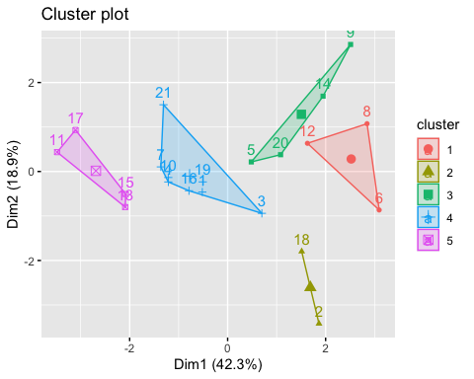

k5

## K-means clustering with 5 clusters of sizes 3, 2, 4, 8, 4  
##   
## Cluster means:  
## Market_Cap Beta PE_Ratio ROE ROA Asset_Turnover  
## 1 -0.87051511 1.3409869 -0.05284434 -0.6184015 -1.1928478 -0.4612656  
## 2 -0.43925134 -0.4701800 2.70002464 -0.8349525 -0.9234951 0.2306328  
## 3 -0.76022489 0.2796041 -0.47742380 -0.7438022 -0.8107428 -1.2684804  
## 4 -0.03142211 -0.4360989 -0.31724852 0.1950459 0.4083915 0.1729746  
## 5 1.69558112 -0.1780563 -0.19845823 1.2349879 1.3503431 1.1531640  
## Leverage Rev_Growth Net_Profit_Margin  
## 1 1.36644699 -0.6912914 -1.320000179  
## 2 -0.14170336 -0.1168459 -1.416514761  
## 3 0.06308085 1.5180158 -0.006893899  
## 4 -0.27449312 -0.7041516 0.556954446  
## 5 -0.46807818 0.4671788 0.591242521  
##   
## Clustering vector:  
## 1 2 3 4 5 6 7 8 9 10 11 12 13 14 15 16 17 18 19 20 21   
## 4 2 4 4 3 1 4 1 3 4 5 1 5 3 5 4 5 2 4 3 4   
##   
## Within cluster sum of squares by cluster:  
## [1] 15.595925 2.803505 12.791257 21.879320 9.284424  
## (between_SS / total_SS = 65.4 %)  
##   
## Available components:  
##   
## [1] "cluster" "centers" "totss" "withinss" "tot.withinss"  
## [6] "betweenss" "size" "iter" "ifault"

Distance <- dist(Pharmaceuticals2, method = "euclidian")  
fviz_dist(Distance)

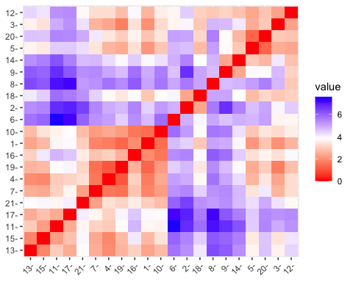

Fitting <- kmeans(Pharmaceuticals2,5)  
aggregate(Pharmaceuticals2,by = list(Fitting$cluster), FUN = mean)

## Group.1 Market_Cap Beta PE_Ratio ROE ROA  
## 1 1 1.69558112 -0.1780563 -0.1984582 1.2349879 1.3503431  
## 2 2 -0.66114002 -0.7233539 -0.3512251 -0.6736441 -0.5915022  
## 3 3 -0.96247577 1.1949250 -0.3639982 -0.5200697 -0.9610792  
## 4 4 -0.52462814 0.4451409 1.8498439 -1.0404550 -1.1865838  
## 5 5 0.08926902 -0.4618336 -0.3208615 0.3260892 0.5396003  
## Asset_Turnover Leverage Rev_Growth Net_Profit_Margin  
## 1 1.153164e+00 -0.4680782 0.4671788 0.5912425  
## 2 -1.537552e-01 -0.4040831 0.6917224 -0.4005718  
## 3 -1.153164e+00 1.4773718 0.7120120 -0.3688236  
## 4 -3.330669e-16 -0.3443544 -0.5769454 -1.6095439  
## 5 6.589509e-02 -0.2559803 -0.7230135 0.7343816

Pharmaceuticals3 <- data.frame(Pharmaceuticals2,Fitting$cluster)  
Pharmaceuticals3

## Market_Cap Beta PE_Ratio ROE ROA Asset_Turnover  
## 1 0.1840960 -0.80125356 -0.04671323 0.04009035 0.2416121 -5.121077e-16  
## 2 -0.8544181 -0.45070513 3.49706911 -0.85483986 -0.9422871 9.225312e-01  
## 3 -0.8762600 -0.25595600 -0.29195768 -0.72225761 -0.5100700 9.225312e-01  
## 4 0.1702742 -0.02225704 -0.24290879 0.10638147 0.9181259 9.225312e-01  
## 5 -0.1790256 -0.80125356 -0.32874435 -0.26484883 -0.5664461 -4.612656e-01  
## 6 -0.6953818 2.27578267 0.14948233 -1.45146000 -1.7127612 -4.612656e-01  
## 7 -0.1078688 -0.10015669 -0.70887325 0.59693581 0.8617498 9.225312e-01  
## 8 -0.9767669 1.26308721 0.03299122 -0.11237924 -1.1677918 -4.612656e-01  
## 9 -0.9704532 2.15893320 -1.34037772 -0.70899938 -1.0174553 -1.845062e+00  
## 10 0.2762415 -1.34655112 0.14948233 0.34502953 0.5610770 -4.612656e-01  
## 11 1.0999201 -0.68440408 -0.45749769 2.45971647 1.8389364 1.383797e+00  
## 12 -0.9393967 0.48409069 -0.34100657 -0.29136529 -0.6979905 -4.612656e-01  
## 13 1.9841758 -0.25595600 0.18013789 0.18593083 1.0872544 9.225312e-01  
## 14 -0.9632863 0.87358895 0.19240011 -0.96753478 -0.9610792 -1.845062e+00  
## 15 1.2782387 -0.25595600 -0.40231769 0.98142435 0.8429577 1.845062e+00  
## 16 0.6654710 -1.30760129 -0.23677768 -0.52338423 0.1288598 -9.225312e-01  
## 17 2.4199899 0.48409069 -0.11415545 1.31287998 1.6322239 4.612656e-01  
## 18 -0.0240846 -0.48965495 1.90298017 -0.81506519 -0.9047030 -4.612656e-01  
## 19 -0.4018812 -0.06120687 -0.40231769 -0.21181593 0.5234929 4.612656e-01  
## 20 -0.9281345 -1.11285216 -0.43297324 -1.03382590 -0.6979905 -9.225312e-01  
## 21 -0.1614497 0.40619104 -0.75792214 1.92938746 0.5422849 -4.612656e-01  
## Leverage Rev_Growth Net_Profit_Margin Fitting.cluster  
## 1 -0.21209793 -0.52776752 0.06168225 5  
## 2 0.01828430 -0.38113909 -1.55366706 4  
## 3 -0.40408312 -0.57211809 -0.68503583 2  
## 4 -0.74965647 0.14744734 0.35122600 5  
## 5 -0.31449003 1.21638667 -0.42597037 2  
## 6 -0.74965647 -1.49714434 -1.99560225 4  
## 7 -0.02011273 -0.96584257 0.74744375 5  
## 8 3.74279705 -0.63276071 -1.24888417 3  
## 9 0.61983791 1.88617085 -0.36501379 3  
## 10 -0.07130879 -0.64814764 1.17413980 5  
## 11 -0.31449003 0.76926048 0.82363947 1  
## 12 1.10620040 0.05603085 -0.71551412 3  
## 13 -0.62166634 -0.36213170 0.33598685 1  
## 14 0.44065173 1.53860717 0.85411776 3  
## 15 -0.39128411 0.36014907 -0.24310064 1  
## 16 -0.67286239 -1.45369888 1.02174835 5  
## 17 -0.54487226 1.10143723 1.44844440 1  
## 18 -0.30169102 0.14744734 -1.27936246 4  
## 19 -0.74965647 -0.43544591 0.29026942 5  
## 20 -0.49367621 1.43089863 -0.09070919 2  
## 21 0.68383297 -1.17763919 1.49416183 5

library(cluster)  
clusplot(Pharmaceuticals2,Fitting$cluster, color = TRUE, shade = TRUE,   
 labels = 2,  
 lines = 0)

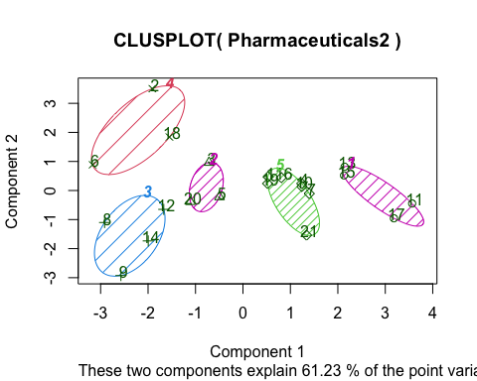

#Task 2  
#Interpret the clusters with respect to the numerical variables used in forming the clusters.  
  
aggregate(Pharmaceuticals2, by = list(Fitting$cluster), FUN = mean)

## Group.1 Market_Cap Beta PE_Ratio ROE ROA  
## 1 1 1.69558112 -0.1780563 -0.1984582 1.2349879 1.3503431  
## 2 2 -0.66114002 -0.7233539 -0.3512251 -0.6736441 -0.5915022  
## 3 3 -0.96247577 1.1949250 -0.3639982 -0.5200697 -0.9610792  
## 4 4 -0.52462814 0.4451409 1.8498439 -1.0404550 -1.1865838  
## 5 5 0.08926902 -0.4618336 -0.3208615 0.3260892 0.5396003  
## Asset_Turnover Leverage Rev_Growth Net_Profit_Margin  
## 1 1.153164e+00 -0.4680782 0.4671788 0.5912425  
## 2 -1.537552e-01 -0.4040831 0.6917224 -0.4005718  
## 3 -1.153164e+00 1.4773718 0.7120120 -0.3688236  
## 4 -3.330669e-16 -0.3443544 -0.5769454 -1.6095439  
## 5 6.589509e-02 -0.2559803 -0.7230135 0.7343816

Pharmacy <- data.frame(Pharmaceuticals2,k5$cluster)  
Pharmacy

## Market_Cap Beta PE_Ratio ROE ROA Asset_Turnover  
## 1 0.1840960 -0.80125356 -0.04671323 0.04009035 0.2416121 -5.121077e-16  
## 2 -0.8544181 -0.45070513 3.49706911 -0.85483986 -0.9422871 9.225312e-01  
## 3 -0.8762600 -0.25595600 -0.29195768 -0.72225761 -0.5100700 9.225312e-01  
## 4 0.1702742 -0.02225704 -0.24290879 0.10638147 0.9181259 9.225312e-01  
## 5 -0.1790256 -0.80125356 -0.32874435 -0.26484883 -0.5664461 -4.612656e-01  
## 6 -0.6953818 2.27578267 0.14948233 -1.45146000 -1.7127612 -4.612656e-01  
## 7 -0.1078688 -0.10015669 -0.70887325 0.59693581 0.8617498 9.225312e-01  
## 8 -0.9767669 1.26308721 0.03299122 -0.11237924 -1.1677918 -4.612656e-01  
## 9 -0.9704532 2.15893320 -1.34037772 -0.70899938 -1.0174553 -1.845062e+00  
## 10 0.2762415 -1.34655112 0.14948233 0.34502953 0.5610770 -4.612656e-01  
## 11 1.0999201 -0.68440408 -0.45749769 2.45971647 1.8389364 1.383797e+00  
## 12 -0.9393967 0.48409069 -0.34100657 -0.29136529 -0.6979905 -4.612656e-01  
## 13 1.9841758 -0.25595600 0.18013789 0.18593083 1.0872544 9.225312e-01  
## 14 -0.9632863 0.87358895 0.19240011 -0.96753478 -0.9610792 -1.845062e+00  
## 15 1.2782387 -0.25595600 -0.40231769 0.98142435 0.8429577 1.845062e+00  
## 16 0.6654710 -1.30760129 -0.23677768 -0.52338423 0.1288598 -9.225312e-01  
## 17 2.4199899 0.48409069 -0.11415545 1.31287998 1.6322239 4.612656e-01  
## 18 -0.0240846 -0.48965495 1.90298017 -0.81506519 -0.9047030 -4.612656e-01  
## 19 -0.4018812 -0.06120687 -0.40231769 -0.21181593 0.5234929 4.612656e-01  
## 20 -0.9281345 -1.11285216 -0.43297324 -1.03382590 -0.6979905 -9.225312e-01  
## 21 -0.1614497 0.40619104 -0.75792214 1.92938746 0.5422849 -4.612656e-01  
## Leverage Rev_Growth Net_Profit_Margin k5.cluster  
## 1 -0.21209793 -0.52776752 0.06168225 4  
## 2 0.01828430 -0.38113909 -1.55366706 2  
## 3 -0.40408312 -0.57211809 -0.68503583 4  
## 4 -0.74965647 0.14744734 0.35122600 4  
## 5 -0.31449003 1.21638667 -0.42597037 3  
## 6 -0.74965647 -1.49714434 -1.99560225 1  
## 7 -0.02011273 -0.96584257 0.74744375 4  
## 8 3.74279705 -0.63276071 -1.24888417 1  
## 9 0.61983791 1.88617085 -0.36501379 3  
## 10 -0.07130879 -0.64814764 1.17413980 4  
## 11 -0.31449003 0.76926048 0.82363947 5  
## 12 1.10620040 0.05603085 -0.71551412 1  
## 13 -0.62166634 -0.36213170 0.33598685 5  
## 14 0.44065173 1.53860717 0.85411776 3  
## 15 -0.39128411 0.36014907 -0.24310064 5  
## 16 -0.67286239 -1.45369888 1.02174835 4  
## 17 -0.54487226 1.10143723 1.44844440 5  
## 18 -0.30169102 0.14744734 -1.27936246 2  
## 19 -0.74965647 -0.43544591 0.29026942 4  
## 20 -0.49367621 1.43089863 -0.09070919 3  
## 21 0.68383297 -1.17763919 1.49416183 4

#CLuster 1:- JNJ, MRK, GSK, PFE  
#Cluster 1: Highest Market_Cap and lowest Beta/PE Ratio  
#Cluster 2:- AHM, WPI, AVE  
#Cluster 2: Highest Revenue Growth and lowest PE/Asset Turnover Ratio  
#Cluster 3:- CHTT, IVX, MRX, ELN  
#Cluster 3: Highest Beta/leverage/Asset Turnover Ratio and lowest   
#Net_Profit_Margin, PE ratio and Marke#Cluster  
#Cluster 4:- AGN,BAY, PHA  
#Cluster 4: Highest PE ratio and lowest Leverage/Asset_Turnover  
#Cluster 5:- ABT, WYE, AZN, SGP, BMY, NVS, LLY  
#Cluster 5: Highest Net_Proft_Margin and lowest Leverage

#Task3  
#Is there a pattern in the clusters with respect to the numerical   
#variables (10 to 12)? (those \n #not used in forming the clusters)  
  
S1 <- Pharmaceuticals_SLV[12:14] %>% mutate(Clusters=k5$cluster)  
ggplot(S1, mapping = aes(factor(Clusters), fill =Median_Recommendation))+geom_bar(position='dodge')+labs(x ='Clusters',y ='Frequence')

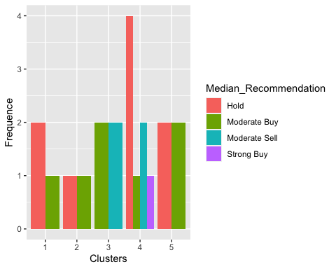

ggplot(S1, mapping = aes(factor(Clusters),fill = Location))+  
 geom_bar(position = 'dodge')+labs(x ='Clusters',y = 'Frequence')

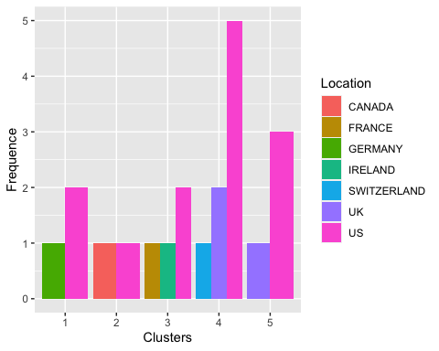

ggplot(S1, mapping = aes(factor(Clusters),fill = Exchange))+geom_bar(position = 'dodge')+  
 labs(x ='Clusters',y = 'Frequence')

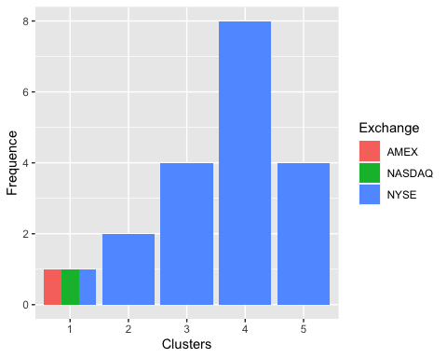

#The graphs above show that there is a slim pattern in the clusters.  
  
#Although the cluster 1 has a different Hold and Moderate Buy median, a different count from the US and Germany, and a different country count, the firms are evenly divided among AMEX,NASDAQ and NYSE.  
  
#The cluster 2 is only listed on the NYSE, has equal Hold and Moderate Buy medians, and is evenly divided across the US and Canada.  
  
##Cluster 3 is a stock that is listed on the NYSE and has distinct counts for France, Ireland, and the US in addition to equal Moderate Buy and Sell medians.  
  
#In Cluster 4, the Moderate Buy, Strong Buy, and Hold medians are in order of greatest to lowest. They are listed on the NYSE and originated from the US, the UK, and Switzerland.  
  
#Cluster 5 is distributed throughout the United States and the United Kingdom, has the same hold and moderate buy medians, and is also listed on the NYSE.

#TASK 4  
#Provide an appropriate name for each cluster using any or all of the variables in the dataset.   
  
#Cluster 1 :- Buy Cluster  
#Cluster 2 :- Sceptical Cluster  
#Cluster 3 :- Moderate Buy Cluster  
#Cluster 4 :- Hold Cluster  
#Cluster 5 :- High Hold Cluster